

S S’ddh rth

CAE ab

CNC Part Pr ograms Using G & M Codes (FANUc Controller)

# G90 PLAIN TURNIN G CYCLE [BILLET X20 Z51

G21 G98

G28 U0 wo

N06 T0404

# N03 S1200

G00 X21 Z2

# (Box turning cycle

G90 X20 Z-30 F60

X19 X18 X17 X16 X15 X14 X13 X12 X11 X 10

G28 U0 W0

N05

M 02



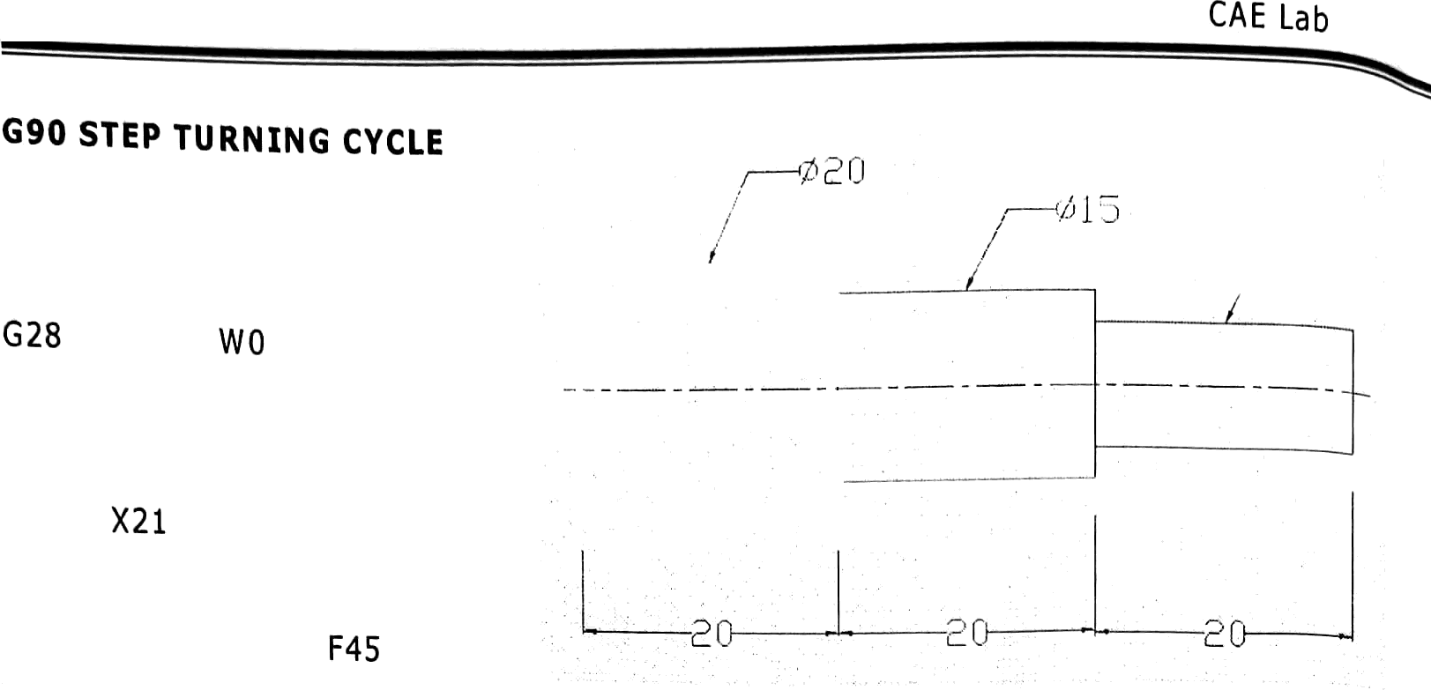

Sri Siddhartha Institute of Technology, Tumkur

IBILLET K20 Z61

G21 G98 U0

N06 T0202

N03 St200 G00 y¿

(Box turning cycle

|  |  |  |
| --- | --- | --- |
| G90 | X20 | z-zo |
| X19 |  |  |
| X18 |  |  |
| X17 |  |  |
| X16 |  |  |
| X15 |  |  |
| X14 |  |  |
| X13 |  |  |
| X12 |  |  |
| XI 1 |  |  |
| X10  G00 | Xz1 | z-zo |
| G90  X19 | X20 | Z-40 F45 |
| X18 |  |  |
| X17 |  |  |
| X16 |  |  |
| G28 | U0 | W0 |
| N05 |  |  |
| N02 |  |  |





# G90 tANNED ROUGHING CYCLE [BILLET X32 Z95

|  |  |  |  |
| --- | --- | --- | --- |
| G21  N06 | G98 G40  T010t |  |  |
| N03 | S1000 |  |
| G00 G90 | X32 Z1  X30 Z-90 | F50 |
| X28 X26 | Z-20 |  |
| X24 |  |  |
| X22 X20 G00 | X16 Z0 |  |
| G03 | X20 Z-2 | R10 | F30 |
| G00  X12 G03 | X20 Z0  X20 Z-4 | R10 | F30 |
| G00 X8 G03 | X20 Z0  X20 Z-6 | R10 | F30 |
| G00 X4 G03 | X20 Z0  X20 Z-8 | R10 | F30 |
| G00  X0 G03 | X20 Z0  X20 Z-10 | R10 | F30 |
| G00 G90 X30 X30  X30 | X30 Z-20  X30 Z-45 R-2  R-3  R-4 | R 1 | F50 |
| X30 | R-5 |  |  |
| G00 G90 | X30 Z-55  X28 Z-80 | R1 | F50 |
| X26 | R2 |  |  |
| X24 X22 X20  G00 G90 | R3 R4 RS  X30 Z-80  X28 Z-90 | F50 |  |
| X26 X24 X22  X20 G28 | U0 W0 |  |  |
| HOS | N30 |  |  |

Sri Siddhartha Institute of Technology, Turn kur

G9O tANNED ROUGHING CYCLE,

G03 CCW CIRCULAR INTERPOLATION CYCLE,

[BILET X32 Z95

CAE Lab

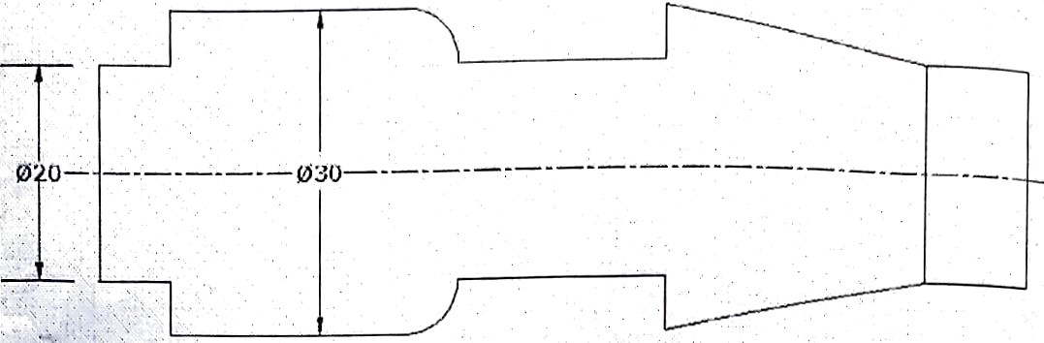



F50

|  |  |  |  |
| --- | --- | --- | --- |
| G21  G28 | G98  u0 | G40  wo |  |
| N06  80s | T0101  stooo |  |
| G00 | X32 | \ |
| G90 | X30 | z-90 | F50 |
| X28 | Z-10 |  |  |
| X26 |  |  |  |
| X24 |  |  |  |
| X22 |  |  |  |
| X20 |  |  |  |
| G00 | X30 | Z-10 |  |
| G90 | X30 | Z-35 | R-1 |
| X30 | R-2 |  |  |
| X30 | R-3 |  |  |
| X30 | R-4 |  |  |
| X30 | R-5 |  |  |
| G28 | U0 | W0 |  |
| N06 | T0303 |  |  |
| G00 | X30 | Z-38 |  |
| G90 | X28 | Z-55 |  |
| X26 |  |  |  |
| X24 |  |  |  |
| X22 |  |  |  |
| X20 |  |  |  |
| GOO | X32 | Z3S |  |
| X30 | Z-83 |  |  |
| G90 | X28 | Z-90 | F50 |
| X26 |  |  |  |
| X24 |  |  |  |
| X22 |  |  |  |
| X20 |  |  |  |
| G28 | U0 | W0 |  |
| N06 | TI |  |  |
| G00 | X26 | Z-55 |  |
| X20 |  |  |  |
| G03 | X30 | Z-60 | R5 |
| G28 | U0 | W0 |  |
| fJ05 |  |  |  |
| M30 |  |  |  |

F50



# o e h o g

G90 C ANNED ROUGHIN G CYCLE

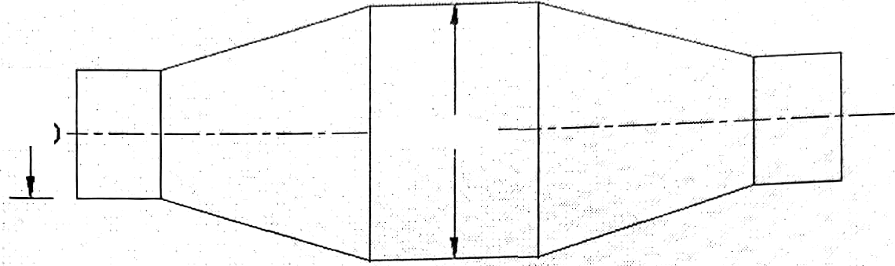[BILLET X20 Z60

— O20

|  |  |  |  |
| --- | --- | --- | --- |
| G21 | G98 |  |  |
| G28 | U0 | W0 |
| N 03 | S1200 |  |
| N 06 | T1212 |  |
| G00 | X20 | Z1 |
| G90  X19 | X20 | Z-54 | F30 |
| X18 |  |  |  |
| X17 | Z-6 |  |  |
| X16 |  |  |  |
| X15 |  |  |  |
| X14 |  |  |  |
| X13 |  |  |  |
| X12 |  |  |  |
| XI1 |  |  |  |
| X10 |  |  |  |
| G00 | X18 | Z-6 |  |
| G90 | X18 | Z-21 | R0 F30 |
| X18 | R-0.5 |  |  |
| X 18 | R-1.0 |  |  |
| X18 | R-1.5 |  |  |
| X 18 | R-2.0 |  |  |
| X 18 | R-2.5 |  |  |
| X18 | R-3.0 |  |  |
| X 18 | R-3.5 |  |  |
| X18 | R-4.0 |  |  |
| G28 | U0 | W0 |  |
| N06 | TO101 |  |  |
| G00 | X20 | Z-33 |  |
| G90 | X18 | Z-48 | R0 F30 |
| X17 | R0.5 |  |  |
| X16 | RI.0 |  |  |
| X1S | R1.5 |  |  |
| X14 | R2.0 |  |  |
| X13 | R2.5 |  |  |

# Sri Siddhartha Institute of Technology, Tumkur X12 R3.0

X11 R3.5

# X10 R4.0

G00 X18 Z-48 G28 U0 W0 N06 T0303

G00 X20 Z-48

G90 X18 Z-54 F30 X17

X16

Xl5 X14 X 13 X12 X11 X10

# G28 U0 W0 N05

N30

CAE Lab



S S’ddh rth

# o cA b

G90 CANNED ROUGHING CY CLE G72 NULTIPLE rACIN CYCLE

N10 [BILLET X30 Z60

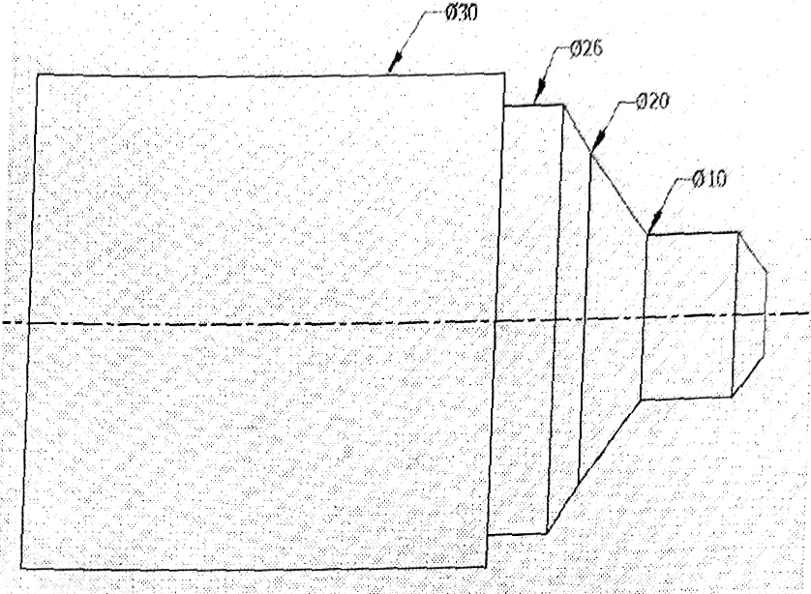

# N20G21 G40 ugg

N30G28 U0 W0

N40 M06 T0808

N50 N03 S1200

# h60 G00 x31 zz

N70 G90 X30 Z-05

N80 G72 W0.5 R0.5

N 90 G72 P9O §180 U0.2 W0.1

N100 G01 Z-22.5 F40 N110 X30

N120 X26

N130 Z-17.5

|  |  |  |
| --- | --- | --- |
| N140 X20  N150 Z-10 | Z-15 |  |
| N160 G02 | X10 | RS F40 |
| N170 G0t  N180 X5 | Z-2.5  Z0 | F50 |
| N190 Z0.5 |  |  |
| N200 G70 | P90 | §180 |
| N210 G28 | U0 | W0 |
| N220 N05 |  |  |
| N230 N30 |  |  |

Department of Nechanical Engineering 7T



Sri Siddhartha Institute of Technology, Tumkur

G71 ROUGH TURINING CANNED CYCLE G90 CANNED ROUGHING CYCLE

G76 THREADING CYCLE (CANNED)

N 10 [BALLET X20 Z60 N20 G21 G40 G98

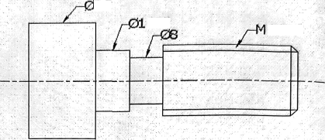

2D

L5

1Zx2

N30 G28 U0 W0

N 40 N06 TO101

N50 N03 S1 200

N60 G00 X21 Z2

N 70 G71 U0.5 RI

N80 G71 P80 §110 U0.1 W0.1

N90 G01 X1 2

N100 X20 N 1 10 Z-05

N 120 G70 P80 q110

N 130 G28 U0 W0 N 140 N06 T0303

0 150 N03 S1200

N 160 00 X12 Z-20

N 170 G90 X1 1.5 Z-25 F30 N 180 X1 1.0

N 190 X10.5 N200 X9.5 N210 X9.0 N220 X8.5 N230 X8.0

N240 G00 X22 Z-25 N250 G28 U0 W0 N260 N06 T0505

N270 N03 S600 N280 G00

CAE Lab

 



Sri Siddhartha In stitute Of

# G90 CANN ED ROUGHING tYCLE

G92 SINGLE PASS THREAD ING CYCLE G74 PECK DRILLING CANNED CyCLE

[BILLET X50 Z65

G28 G98

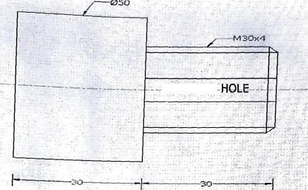

—THROUGH

G28 U0 W0

M03 S 1200

M06 T0808

G00 X50 Z2

C90 X50 Z-30 F45

X48 X46

X42 X40 X38 X36 X34 X32 X30

G00 X50 Z2 G28 U0 W0 H06 T0S05 G00 X29.2 Z1

G92 X29.2 Z-29 FI.S X28.8 Z-29.5

X28.6 Z-29.5 X28.4 Z-29.5 X28.2SZ-29.5 X28.2OZ-29.5 X28.16Z-29.5 G00 X30 Z2 G28 U0 W0 1406 T0404

H03 S600

G00 X0 Z2

Department of Hechanical Engineering 73



*^ S *ddh@ ha Institute o*f* Technology, Tumkur G 74 R2.0



*G7q* yą Z-30 P1000 R1 F40

G00 y yy

G28 uo W0

N05 N30

CA S Lab

